Thursday, 25 April 2024
Business Development Coordinator
Phoenix Youth Provision


Risk Assessment Policy 2024
Contents

1. Introduction 1
2. What is a Risk Assessment? 1
3. When would we do a Risk Assessment? 2
4. What are Control Measures 2
5. Five Steps to Risk Assessment 2
5.1. Step 1 – Identify the Hazards. 2
5.2. Step 2 – Identify who might be harmed and how. 2
5.3. Step 3 – Evaluate the risks and decide on precautions. 2
5.3.1. Severity 2
5.3.2. Serious risk - action required if practicable. 2
5.3.3. Medium risk - further risk reduction if practicable 3
5.3.4. Low risk - no further action required. 3
5.4. Step 4 – Record and Implement the Findings 3
5.5. Step 5 – Review 3
6. Guidance 4
6.1. Example NYA risk assessment template 4

Introduction
Health and Safety legislation requires every employer to carry out a “suitable and sufficient” assessment of the risks to health and safety of both employees, volunteers and people not in their employment arising out of or in connection with their work activities. The law does not require that we eliminate all risk, but to protect people as far as ‘reasonably practicable’. For significant risks these assessments should be formally documented, and all staff made aware.
At Phoenix Youth Provision it is the responsibility of the board of Directors to ensure risk assessments are conducted. The actual assessment process may be delegated to other members of staff who are responsible for controlling the risk.

What is a Risk Assessment?
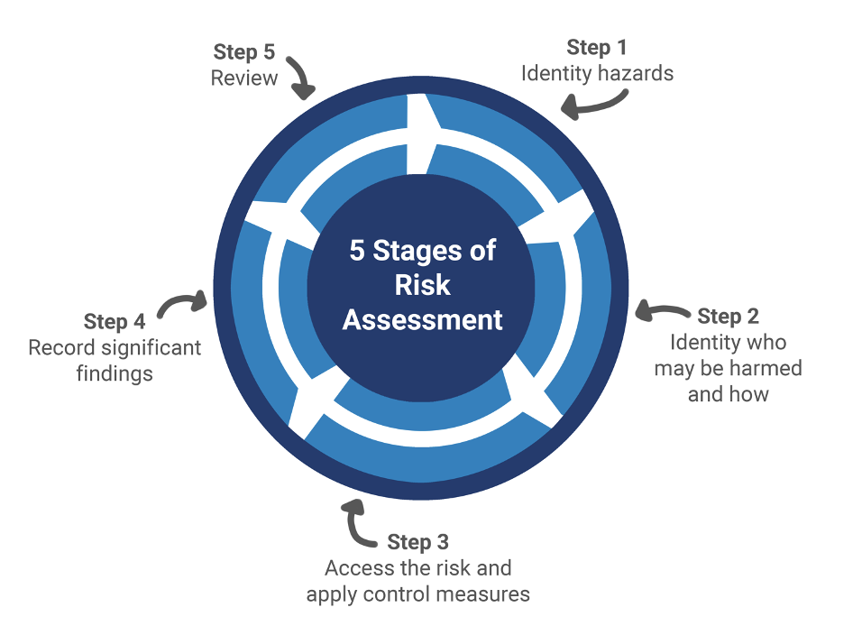
A risk assessment is nothing more than a careful examination of how people could be harmed from a particular activity or situation. The assessment helps to identify the likelihood of harm and whether adequate precautions have been taken or if further control measures should be introduced to reduce the risk of harm to as low a level as possible.

When would we do a Risk Assessment?
There is an expectation that Risk Assessments will be carried out for all activities that present a risk. Written risk assessments must be completed for all PYP sessions, off site events, and trips.

What are Control Measures
Action taken to prevent someone being harmed. For example, labelling and storing hazardous substance securely.

Five Steps to Risk Assessment

Step 1 – Identify the hazards.
In most cases these can simply be identified by observation of the session /area and consulting with those staff involved in the activity.

Step 2 – Identify who might be harmed and how.
The next step is to decide who might be affected by the hazard/s. This could include staff, young people, volunteers, contractors, visitors and/or members of the public.
Some individuals may have particular requirements e.g. new and young employees, or those with disabilities / medical conditions etc. and may be at particular risk.

Step 3 – Evaluate the risks and decide on precautions.
Having identified the hazards you must now decide what to do about them by considering the existing procedures and controls in place and determine if any additional actions need to be taken. i.e. whether you have done all that is reasonably practicable to reduce the risk of harm occurring. Ensure all of the control measures you have in place against each identified hazard are listed.
In evaluating the risk, the likelihood of harm occurring and the severity of potential injury should be considered. This will help identify the urgency of control measures and whether, following the introduction of controls the risk can be reduced sufficiently. This may be done using a simple High, Medium and Low.

Severity
High Risk, reduction required - high priority. May only take place if good control measures can be implemented.

Serious risk - action required if practicable.
If it is not possible to lower risk further, you will need to consider the risk against the benefit so far as is reasonably practical.

Medium risk - further risk reduction if practicable

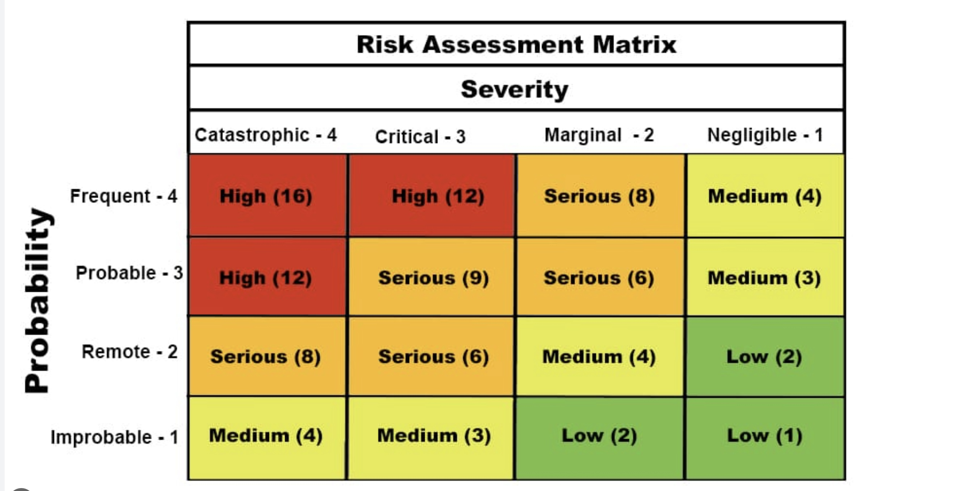
Low risk - no further action required.

Step 4 – Record and Implement the Findings
A risk assessment must be suitable and sufficient, the level of detail in a risk assessment should be proportional to the risk. The purpose is not to detail each trivial hazard but to ensure that significant hazards are adequately assessed with the aim of informing safe working practices. In most cases the use of simple bullet pointed controls would be sufficient. Staff should be involved throughout the risk assessment process and upon completion risk assessments should be centrally filed and shared with all those (staff, contractors etc.) who may be affected.
- Completed risk assessments should be signed off by the person.
- Completing the assessment and should be agreed by the board of Directors.

Step 5 – Review
Risk assessments should be reviewed regularly i.e. annually or as soon as any significant changes have occurred. You should review a risk assessment immediately after there has been an accident or incident to identify what went wrong and whether any additional controls are required. The Directors will be responsible for checking the review.
Young People should be taught:
• about hazards, risks and risk control;
• to recognise hazards, assess consequent risk and take steps to control the risks to themselves and others;
• to use information to assess the immediate and cumulative risks;
• to manage their environment to ensure the health and safety of themselves and others;
• to explain the steps they take to control risks.

Guidance
This guidance aims to familiarise PYP staff with some of the terms used and how to share the concept of risk and develop young people’s ability to assess and control risks.
Some terms explained:
• Hazard means anything that can cause harm.
• Risk control involves taking steps to reduce the chance, and/or mitigate the consequences, of the hazard causing harm.
• Risk assessment evaluates the risks and decides whether precautions are adequate or more should be done.
Directors and staff are aware of the concept of risk to their children through risk assessment training. Consistent messages on risk awareness, delivered at the appropriate developmental level throughout a young person’s time at PYP, will result in them being better equipped to deal with situations of uncertainty and change.
Talking about the concept of risk will help young people make their own decisions about risk so that they can:
• recognise the existence of hazards, risks and uncertainty in a range of contexts;
• assess their own ability, and the ability of others, to deal with different levels of risk
• assess the consequences when dealing with hazards presented to themselves and to others
• seek advice from appropriate sources to minimise and manage risk;
• understand that rules and regulations follow from risk assessments and that they have an individual and collective responsibility.
In the future, young people's ability to assess and control risks will be increasingly important in recreational, training or work time.
All staff are required to complete risk assessments throughout the session on an informal basis, and report or act accordingly.

NYA Risk Assessment Template
An NYA risk assessment template can be downloaded here.

