

Recording Form for Safeguarding Concerns

Staff, volunteers and regular visitors are required to complete this form and pass it to safeguarding@phoenixyouthprovision.org.uk , 07561854880 DSL if they have a safeguarding concern, at least by the end of the session, but earlier if possible.
Information Required | Enter Information Here
Full name of young person
Date of birth
Group.
Your name
Nature of concern/disclosure
Please include where you were when the child made a disclosure, what you saw, who else was there, what did the child say or do and what you said.
[Ensure that if there is an injury this is recorded on body map (size, colour and situation.)
[Make it clear if you have a raised a concern about a similar issue previously]
Time & date of incident:
Name and position of the person you passing this information to?
Your Signature
Time and date form completed
Time form received by DSL | DSL TAKES OVER FROM HERE
Action Taken by DSL
Referral made to Early Help
Referral made to police
Referral made to Social Care
Outcome of any referral if known
Referral Made to Other Agency
Parents Informed
If not reason why not.
Update chronology and consider further action if necessary
Feedback given to youth team
Feedback given to parent
Feedback given to young person

Feedback given to person who recorded disclosure
Further Action Agreed
Full Name of DSL
Signature of DSL
Date of Signature

Body Map
Older Child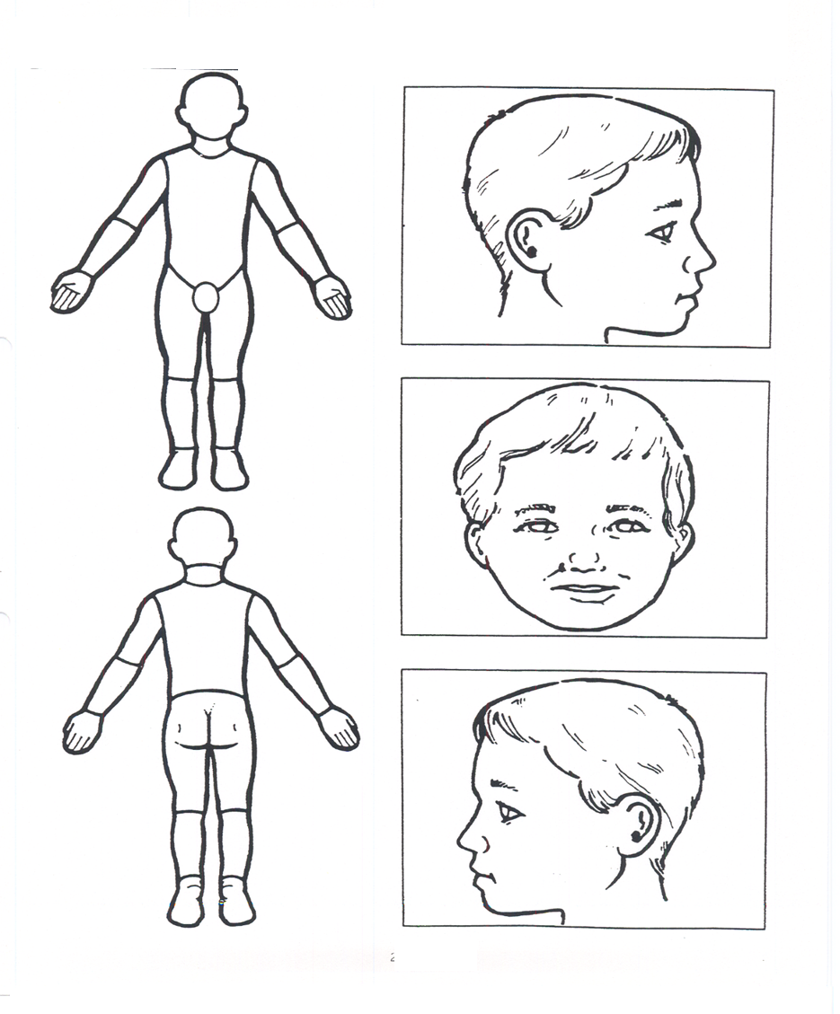
Indicate clearly where the injury was seen and attach this to the referral form.

