Phoenix Youth Provision Business Plan 2025

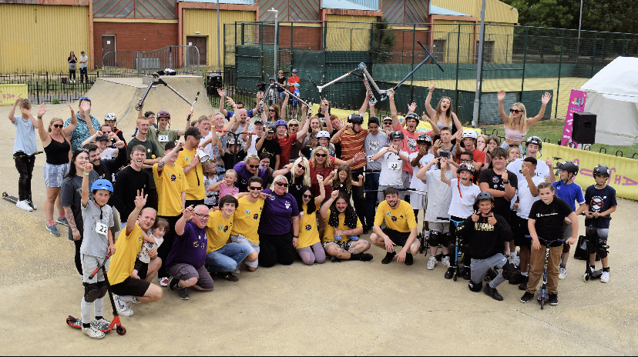

Vision

Phoenix Youth Provision’s vision is to provide a vibrant and engaging community space, that meets the need of the young people in the local community, providing a safe and welcoming environment for young people to socialise, learn new skills, and have fun.

Mission

To provide a robust and planned programme of good quality youth work, designed for the purpose of aiding and enhancing the personal and social development of young people through their voluntary involvement.

Values

We follow the values and principles of youth work:
The young person chooses to be involved, not least because they want to relax, meet friends and have fun.
Youth work must build from where young people are.
Youth work operates on young people’s own personal and recreational territory – within both their geographic and interest communities.
The young person is recognised as an active partner who can, and should, have opportunities and resources to shape their lives.

Assessment of the external content

The parish of Whittlesey is located in the east of England and sits inside the boundary of Fenland district Council. It consists of Whittlesey, the villages of Coates, Eastrea, Pondersbridge, Turves, and Benwick. Whittlesey has a population of about 20,000 people, 4,000 of those being under the age of 18.
The nearest city is Peterborough, which sits to the west of Whittlesey. The towns of Wisbech, March and Chatteris also sit inside the Fenland boundary.
Whittlesey parish sits within a distinctive, historic wet landscape, which contributes to its beauty and biodiversity, but also causes flooding issues.
It has a unique, cultural heritage, with Bronze age history, historic conservation areas, listed buildings, the unique, mud walls, and the popular tradition of the straw bear festival.

Whittlesey has a range of shops and services, but is a rural area, that needs improved, transport, links and work opportunities. There are 5 primary schools and one secondary school, and one secondary school.

Whittlesey and surrounding areas are split in to 5 wards, Bassenhally, St. Andrews, Lattersey, Stonald, and Benwick, Coates and Eastrea.

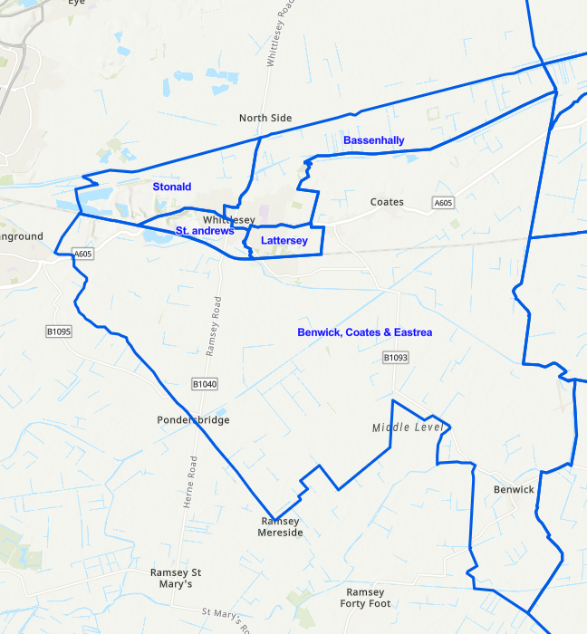

The index of multiple deprivation is the official measure of the relative deprivation for a small area. These areas are called lower super output areas. There is a total of 32,844 LSOA is in England is ranked from 1 to the most deprived to 32,844 for the least deprived. Deprivation does not just cover finances, but a complex range of needs, and a lack of access to resources.

In Peterborough and Cambridgeshire there are 459 LSOAs. Each ward is divided and coded. The lower ranking numbers are the most deprived.

For Whittlesey this means that Lattersey is our most deprived area, and Stonald our least deprived.

Lattersey 006D. Ranked 12th
Bassenhally 006G. Ranked 38th
Benwick and villages 008C. Ranked 44th
St Andrews 006E. Ranked 128th
Stonald 006A. Ranked 168th

Anti-Social Behaviour in Whittlesey

Reported levels of anti-social behaviour show that this is a consistent and significant proportion of this crime in the locality. There is anecdotal evidence that much is created by young people who have limited access to engaging activities like those provided by Phoenix. The statistics provided concern only those incidents reported to the police a significant amount of anti-social behaviour is not reported to the authorities.

 | Nov-20 | Dec-20
Anti-social Behaviour Incidents | 9 | 15
Total Crime Incidents | 75 | 87
% of Total Crime | 12.00% | 17.24%
 | Jan-21 | Feb-21 | Mar-21 | Apr-21 | May-21 | Jun-21 | Jul-21 | Aug-21 | Sep-21 | Oct-21 | Nov-21 |  | Dec-21
Anti-social Behaviour Incidents | 11 | 16 | 16 | 23 | 25 | 13 | 23 | 13 | 14 | 19 | 15 |  | 10
Total Crime Incidents | 62 | 90 | 75 | 104 | 119 | 84 | 107 | 92 | 97 | 99 | 95 |  | 84
% of Total Crime | 17.74% | 17.78% | 21.33% | 22.12% | 21.01% | 15.48% | 21.50% | 14.13% | 14.43% | 19.19% | 15.79% |  | 11.90%
 | Jan-22 | Feb-22 | Mar-22 | Apr-22 | May-22 | Jun-22 | Jul-22 | Aug-22 | Sep-22 | Oct-22 | Nov-22 |  | Dec-22
Anti-social Behaviour Incidents | 13 | 11 | 15 | 10 | 15 | 15 | 12 | 13 | 10 | 22 | 15 |  | 19
Total Crime Incidents | 74 | 93 | 84 | 76 | 114 | 100 | 100 | 120 | 83 | 150 | 81 |  | 97
% of Total Crime | 17.57% | 11.83% | 17.86% | 13.16% | 13.16% | 15.00% | 12.00% | 10.83% | 12.05% | 14.67% | 18.52% |  | 19.59%
 | Jan-23 | Feb-23 | Mar-23 | Apr-23 | May-23 | Jun-23 | Jul-23 | Aug-23 | Sep-23 | Oct-23
Anti-social Behaviour Incidents | 15 | 18 | 21 | 17 | 17 | 15 | 16 | 13 | 20 | 8
Total Crime Incidents | 106 | 83 | 126 | 92 | 103 | 92 | 86 | 98 | 106 | 87
% of Total Crime | 14.15% | 21.69% | 16.67% | 18.48% | 16.50% | 16.30% | 18.60% | 13.27% | 18.87% | 9.20%

Assessment of Internal Capacity and Potential

STRENGTHS

- Directors are very passionate and work well together.
- Directors have complimentary skills and experiences.
- Young people enjoy the sessions.
- Good links developed with Police, education, parents, Clarion, council, sports clubs, community pantry and Support Fenland.
- Staff are willing to train and develop.
- Part of ecosystem data program.
- Past support from almond consultant.
- Some paid staff now in post.
- Excellent relationship with community youth worker.

WEAKNESSES

- Difficulty recruiting new volunteers.
- Sessions occasionally cancelled due to lack of staff.
- Little financial security, all funded at present.
- No specific base for provision.
- Board of directors very small.
- Staff have gaps in training.
- No full time staff.

OPPORTUNITIES

  - Possible share of community building.
  - Funding opportunities available.
  - Building a support group to add strengths.
  - Free or subsidised training available.
- Quite niche youth groups in Fenland so could expand.
- Good understanding of the needs of our community.
- Possibility of more paid staff in the future.

THREATS

- Lack of funding.
  - Loss of temporary building.
- Volunteer staff leaving for paid roles.
  - Community feelings about young people and ASB.
  - 75% of directors nearing retirement age.
  - Another company could set up locally.

Goals and Objectives
Objective 1

To build youth provision in Whittlesey and the surrounding villages.

Rationale ; In 2021 the population of the Whittlesey area was 17,700 people. 11% of these were children aged between 10 and 19 due to continuous house building in the local area, this number will have gone up, meaning there are approximately 2000 young people in the local area.

We will achieve this by:

Researching and understanding our local area. (Complete)

Building relationships with local schools, community organizations, and parents. (Ongoing and very positive)

Develop a diverse range of activities and services that cater to the interests of young people. (Ongoing and positive)

Use Social Media and our website, to reach a wider audience. Appear on local radio. (Complete)

Collaborate with Partners: (ongoing)

Involve young people in the decision-making process.
Allow them to have a say in program development and activities. (Ongoing)

Seek funding through grants, donations, and fundraising efforts.
Ensure your financial plan is sustainable for the long term. (Needs further work)

Continuously assess the impact and effectiveness of your programs.
Use data and feedback to make improvements and adapt to changing needs. (Ongoing)

Create an inclusive environment that welcomes youth from all backgrounds, and ensure your offer address the unique needs of a diverse population. (Complete)

Hire and train staff who are passionate about working with youth, to ensure they have the necessary skills and qualifications. (Ongoing)

Prioritise the the safety and well-being of young people, by implementing policies and procedures to protect their physical and emotional health. (Complete)

Remember that building and marketing youth provision is an ongoing process. It requires dedication, community engagement, and a commitment to meeting the needs of the youth you serve. (Complete)

2025 Update. provision is now running 4 evenings a week, but groups are quite small due to building restrictions or staffing. Youth café under discussion to fill the 5th night.
Objective 2
Support young people to increase their self-esteem and self-confidence.
Rationale; 14% of Fenland is income deprived; out of 316 local authorities, Fenland is ranked 93rd most income deprived.
We will achieve this by:

Positive Reinforcement:. Offer praise and encouragement when they accomplish something or exhibit positive behaviour. Be specific in your praise to highlight their achievements.(ongoing)

Active Listening. Pay attention to their thoughts and feelings. Let them express themselves without judgment, and validate their emotions. (Ongoing)

Set Realistic Expectations to help them set achievable goals, both short-term and long-term, so they can experience success and build confidence gradually.(ongoing)

Foster Independence by Encouraging them to make decisions and solve problems on their own. This autonomy can boost their self-esteem. (Ongoing)

Teach Resilience byEmphasising the importance of learning from failures and setbacks. Resilience can help them bounce back from disappointments.(ongoing)

Offer Constructive Feedback: When providing feedback, we will focus on specific areas for improvement and suggest actionable steps to help them grow. (Ongoing)

Promote a Growth Mindset to Encourage the belief that abilities and intelligence can be developed through effort and learning. This mindset fosters a willingness to take on challenges. (Ongoing)

Provide Opportunities for Skill-Building by engaging them in activities that match their interests and abilities. As they acquire new skills, they'll gain confidence. (Ongoing)

Encourage positive friendships and social interactions, as peers can play a significant role in boosting self-esteem.(ongoing)

Role Modelling, by setting a positive example through our own behaviour and how we handle challenges. They often learn from observing adults. (Ongoing)

Teach the importance of self-care, including physical and emotional well-being. A healthy lifestyle can contribute to improved self-esteem. (Ongoing)

If low self-esteem and confidence are persistent and severe, consider seeking the assistance of a counsellor or therapist who specialises in youth development. (Ongoing)

2025 Update. Young people have been observed to be increasing confidence and self esteem, plus some have moved up a group once these skills have developed.
Lots of work done around youth voice and coproduction.
8 Young people referred to counselling, and 10 currently seeing our youth mentor.
Kick and chips developed through youth voice, fostering team skills, problem solving, social interactions and so on, as well as building solid relationships with trusted adults.

Objective 3

To develop young people's ability to manage their personal and social relationships.

Rationale: Fenland has a higher than average amount of suicides, difficulties in daily living and physical health issues.

We will achieve this by;

Encourage open and honest communication. Teach them active listening and expressing themselves clearly. (Ongoing)

Teach empathy and understanding of others' feelings. Discuss how actions can impact others. (Ongoing)

Help them develop conflict resolution skills, emphasising compromise and finding win-win solutions. (Ongoing)

Teach them the importance of setting and respecting personal boundaries in relationships. (Ongoing)

Educate them on responsible use of social media and online etiquette to prevent cyberbullying and maintain healthy online relationships. (Ongoing)

Discuss peer pressure and ways to resist it. Encourage them to make choices based on their values, not just to fit in. (Ongoing)
Help them build a supportive network of friends, family, and mentors. (Ongoing)

Talk about what makes a healthy relationship, emphasising respect, trust, and mutual support. (Ongoing)

Keep an eye on their relationships, but respect their privacy. Offer guidance when necessary. (Ongoing)

Remember that every young person is unique, so will tailor our approach to their individual needs and circumstances. (Ongoing)

Will create informal learning opportunities for young people to develop new skills, attitudes and knowledge. (Ongoing)

2025 update. All young people are supported in our groups and through mentoring to build the above skills. We also allow young people to become young leaders or volunteers, to further develop them.

Objective 4

Supporting young people with their mental health and emotional well-being is crucial.
Rationale; Fenland ranked in the bottom 20 percent of local authority areas in England for health in 2021.
We will achieve this by:
Encourage open and non-judgmental communication so young people feel comfortable sharing their feelings and concerns. (Ongoing)
Listen actively and empathetically to their thoughts and emotions without interrupting or offering immediate solutions. (Ongoing)
Ensure they feel safe and secure at PYP activities and events. (Ongoing)
Support them to develop healthy coping mechanisms like mindfulness, deep breathing, or journaling. (Needs to be introduced)
Encourage them to set achievable goals and support their efforts to reach them.(ongoing)
Promote regular exercise, a balanced diet, and adequate sleep for overall well-being. (Ongoing)
If needed, connect them with mental health professionals, therapists, or counsellors. (Ongoing)
Encourage them to build and maintain positive friendships and seek support from trusted adults.(ongoing)
Educate them about mental health to reduce stigma and promote understanding.(ongoing)
Be aware of signs of distress, such as withdrawal, changes in behaviour, or academic performance. Lead by example by prioritising self-care and emotional well-being in your own life. (Ongoing)
2025 Update. We ensure young people feel safe by observing and listening, have rules in the group and use a behaviour strategy. Young people all have ample opportunities to speak to the trusted adults in the groups, and these staff also look for any signs of concern.
Sport is part of all sessions to enable young people to be involved in exercise.
Objective 5

To encourage positive group atmosphere and community cohesion:

Rationale; Access to services is difficult in Fenland, due to lack of investment, rurality and poor transport links.
We will achieve this by;

Creating a safe, accessible spaces where young people can gather and participate in activities. (Complete but wanting to take this further)

Establish mentorship programs connecting experienced community members with youth to provide guidance and support. (To be developed)

Empower young people to take on leadership roles in community projects and decision-making. (Partial completion)

Offer a variety of recreational and educational activities such as sports, arts, and workshops. (Complete)

Promote understanding and appreciation of different cultures and backgrounds to foster inclusivity. (Ongoing)

Encourage partnerships between schools, local organisations, and businesses to fund and support youth initiatives. (Ongoing)

Establish effective communication channels, like social media, to keep local people informed about events and opportunities. (Complete)

Organise regular events, festivals, and gatherings to bring the community together. (Needs to be developed)

Encourage both youth and adults to volunteer, fostering a sense of giving back. (Ongoing)

Seek input from the community and youth to adapt and improve programmes over time. (Ongoing)

Offer workshops and seminars on relevant topics like mental health, substance abuse, and bullying. (Ongoing)

Recognise and celebrate the achievements and contributions of youth in the community. (Ongoing)

Advocate for policies and funding that promote youth engagement and community (always!)

2025 Update. We have various activities running to meet the needs of our young people, but are always looking for bigger and better premises. We are a member of Whittlesey Community Hub, and are building good links with GP services, sports clubs, police, schools, community pantry and so on. Currently we are delivering lunch time sessions and workshops in SHSCC, and have looked at pertinent issues such as football hooliganism, crimes, and so on. Funding bids and policies are always prioritised.
Young people are encouraged to volunteer in our clubs and we continually advertise for volunteers from our local community.

Objective 6
To build the capacity of young people to consider risks, make reasoned decisions and take control.

Rationale; Not only is Fenland ranked in the bottom 20 percent of local authority areas in England for health, but their poorest performance area is behavioural risk factors.

We will achieve this by;

Providing comprehensive and age-appropriate education on risk factors, consequences, and decision-making. Teach them about the potential consequences of risky behaviours. (Ongoing)

Create an environment where young people feel comfortable discussing their concerns, thoughts, and experiences. Encourage open dialogues about decision-making. (Complete)

Encourage them to choose friends who have a positive influence and share their values. Friends can play a significant role in shaping behaviour. (Ongoing)

Teach critical thinking skills, including analysing options, considering consequences, and evaluating the pros and cons of a decision. (Ongoing)

Equip young people with problem-solving skills to address challenges and conflicts in a constructive manner. (Ongoing)

Teach emotional management and coping strategies to handle stress and strong emotions without resorting to risky behaviours. (Ongoing)

Encourage them to seek support from trusted adults, mentors, or professionals when facing complex decisions or challenging situations. (Ongoing)

Ensure young people understand the consequences of their actions and that they are accountable for their decisions.(ongoing)

Provide access to accurate information on topics like drugs, alcohol, relationships, and sexual health, so they can make informed decisions. (Ongoing)

2025 Update most of these actions are net either through attending regular building based clubs, during detached or kick and chips, or by the mentor in school.

Performance Measures

To further develop our understanding of outcomes and data collection, we are working with the Ecosystem Data Collection project. This is being run by the George Williams College and will be using the colleges outcomes framework. This includes a self-assessment tool for young people consisting of 26 questions. There is also the option of using the adult rating of youth behaviour and the user-engagement survey. This will help us to demonstrate the effectiveness of our work, areas to improve, and the data will be useful in future funding bids.

2025 Update

