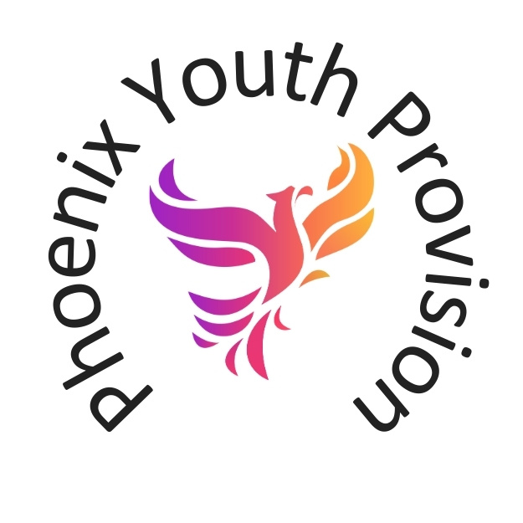
Sunday, 12 March 2023
Kim Kynaston
Phoenix Youth Provision
Behaviour Management Principles and Procedures

Contents
Introduction 1
Principles 1
Participation and Active Involvement 2
Equality, Diversity and Inclusion 2
Partnership with Young People and Others 2
Personal, Social and Political Development 3
Our commitment to young people 3
Behaviour Management Procedure 4
Disciplinary Stages 4
Verbal Challenge 4
Warning – Green 4
Cool Off – Amber 4
Ban – Red 4
Verbal challenge 5
Warning 5
Cool Off 5
Ban 5
Procedure 5
Assessing the Level of Behaviour 6
Low-Level Behaviour (Green) 6
Level Judgements 6
Sanctions 7
Medium-level Behaviour (Amber) 7
Level Judgements 7
Sanctions 8
High-Level Behaviour (Red) 8
Level Judgements 8
Special Consideration 9
Sanctions 9
Accident / Incident Form - Phoenix Youth Provision 11
Personal Information of Person / People Involved. (Use second sheet if needed). 11
Ignite Group Rules 13
Behaviour Contract 14
'No Tolerance' (Red) 14

Introduction
The basis of this document is that we ask all our members to respect the building, respect the staff and respect each other. This document applies to all young people who attend Phoenix Youth Provision CIC. It is also a tool to be utilised by all staff, including paid employees, committee members, freelance and agency workers, volunteers, placement students, parents/carers and support workers or anyone working on behalf of Phoenix Youth Provision. PYP works with young people from the age of 10 to 18.
Phoenix Youth Provision believes that all young people and staff have the right to have access to an environment that is safe, secure and free from negative or anti-social behaviour of any kind. To enable an environment that inspires, promotes individuality and encourages young people to feel comfortable engaging in activities, without the fear of negative or anti-social behaviour, Phoenix Youth Provision sets out clear boundaries in relation to behaviour. Throughout this document it is acknowledged that some inappropriate behaviours may be linked to medical conditions, disabilities or additional needs.

At Phoenix Youth Provision we are committed to preparing young people for the wider world, and as a result, we operate within the notion that the fact a young person has a disability, or additional support need does not mean that they should never be challenged. Instead, we believe that this behaviour document should reflect the need to pay extra attention to the underlying causes of their difficulties, reflect the additional barriers disabled people or individuals with additional support needs face in society and where appropriate, ensure that reasonable adjustments and support is put into place.

Principles
Phoenix Youth Provision is dedicated to providing a safe and secure environment, free from negative and anti-social behaviour for all young people. As part of the ethos of the staff of which we are committed to:
- Ensuring that young people are given clear behaviour boundaries and those who have difficulties meeting these boundaries are supported and helped in ways which are sensitive to their needs.
- Providing safeguards for all staff and volunteers with a clear outline of how to manage behaviour at Phoenix Youth Provision.
- Ensuring that the safety of both young people and staff is treated as equally important.

At Phoenix Youth Provision, all our activities are underpinned by youth work values and practice. Drawn from the Youth Work National Occupational Standards, these values are as follows:

Participation and Active Involvement
- Young people choose to be involved, not least because they want to relax, meet friends, make new relationships, to have fun, and to find support.
- The work starts from where young people are in relation to their own values, views and principles, as well as their own personal and social space.
- It seeks to go beyond where young people start, to widen their horizons, promote participation and invite social commitment, in particular by encouraging them to be critical and creative in their responses to their experience and the world around them.

Equality, Diversity and Inclusion
- It treats young people with respect, valuing each individual and their differences, and promoting the acceptance and understanding of others, whilst challenging oppressive behaviour and ideas.
- It respects and values individual differences by supporting and strengthening young people’s belief in themselves, and their capacity to grow and to change through a supportive group environment.
- It is underpinned by the principles of equity, diversity and interdependence.

Partnership with Young People and Others
- It recognises, respects and is actively responsive to the wider networks of peers, communities, families and cultures which are important to young people, and through these networks seeks to help young people to achieve stronger relationships and collective identities, through the promotion of inclusivity.
- It works in partnership with young people and other agencies which contribute to young people’s social, educational and personal development.
- It recognises the young person as a partner in a learning process, complementing formal education, promoting their access to learning opportunities which enable them to fulfil their potential.

Personal, Social and Political Development
- It is concerned with how young people feel, and not just with what they know and can do.
- It is concerned with facilitating and empowering the voice of young people, encouraging and enabling them to influence the environment in which they live.
- It safeguards the welfare of young people, and provides them with a safe environment in which to explore their values, beliefs, ideas and issues.
Our commitment to staff, volunteers and other’s working on behalf of the organisation: Phoenix Youth Provision strives to create an atmosphere where the principles of managing the behaviour of young people are clearly outlined and easy to follow. All staff will be enabled to confidently and fairly manage behaviour as well as help guide young people to contribute positively to our community, the wider community and society as a whole. We will ensure that all staff receive encouragement, support and training in areas of managing behaviour and have access to opportunities to openly discuss and share the ways in which supporting young people can be developed.

Our commitment to young people
Phoenix Youth Provision is committed to protecting, fulfilling and promoting the rights and safety of young people at our youth provision. Positive behaviour needs to be planned for, modelled, taught and acknowledged and as a result we are committed to ensuring that all staff, including paid employees, freelance and agency workers, volunteers, placement students, support workers or anyone else working on behalf of Phoenix Youth Provision presents themselves as a positive role model to all young people. We seek to ensure that they are fully aware of and understand the behaviours that are acceptable and unacceptable when in or around Phoenix Youth Provision with the aim of enabling them to make positive contributions to our community, the wider community and society as a whole.

Behaviour Management Procedure
When signing up to become a member at Phoenix Youth Provision every young person will be required to read, understand and sign our Group Expectations Form. We understand the need to be consistent in the way that we respond to unacceptable or inappropriate behaviour and we do this by implementing a consistent three levelled approach that provides examples of inappropriate behaviours at each level, appropriate sanctions and steps for dealing with the behaviour. At any time, if someone is unsure of how to proceed, guidance and support can be sort from the Lead Worker on site.

Disciplinary Stages
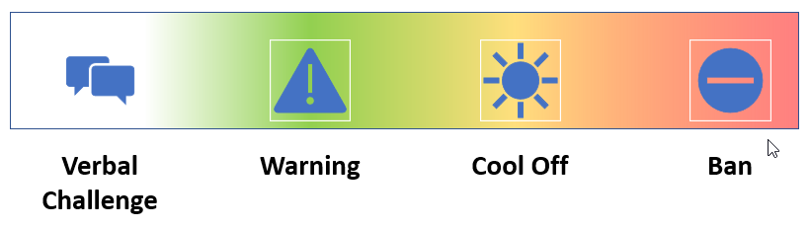
To ensure that this is clear and easy to follow for everyone, we have decided to use Green, Amber, Red (traffic light system) for significant stages. All four colour coded disciplinary stages are show below.

 | Verbal Challenge | Not Recorded
 | Warning – Green | Recorded
 | Cool Off – Amber | Recorded
 | Ban – Red | Recorded

Details of how to place incidents in the correct category are set out below.

Verbal challenge
The young person will be informally reminded that the way they are behaving is not appropriate. A clear explanation as to why this behaviour is inappropriate will be given where necessary, with staff/volunteers taking a non-threatening and encouraging approach at this point, referring to previous positive behaviour whilst providing examples of how to better act or behave. Verbal challenges do not need to be reported to the Lead.
Warning
The young person will be formally reprimanded for the inappropriate behaviour, and this will be recorded.

Cool Off
The young person should be taken to an agreed safe place within the premises for a specified period. Staff will discuss expectations and provide suitable support for the young person aimed at achieving a shared understanding of the issues. Parents will be informed, details recorded, and young person.

Ban
The young person is sent home and is not permitted to enter the youth provision or be within its vicinity. If the behaviour or incident is of an illegal or potentially dangerous nature, we reserve the right to contact the relevant agencies and government bodies, including the police. Bans will be subject to review on an individual basis. This will also include a re-entry meeting between a director, young person and parent/carer, and a victim if appropriate.

Procedure
Staff will always deliver sanctions calmly and with care. It is in nobody’s interest to confront inappropriate behaviour with anger. When a young person is sent home from a session, a cool off is imposed or a ban is put in place, parents/carers of all young people under the age of 18 must be notified and fully informed of the reasoning behind these sanctions. Only young people who have consent to leave Phoenix Youth Provision without a parent/guardian will be allowed to leave independently. However if the young person is distressed/angry, parents/carers must attend to collect their young person immediately. Even when a young person is allowed home alone staff must be confident that it is sensible and safe to send a young person following any incident home on their own. Otherwise, parents/carers must attend to collect their young person immediately. If a young person is deemed as being under the influence of any psychoactive substance (including alcohol) then regardless of consent to leave Phoenix Youth Provision independently they must be collected by a parent/guardian immediately or the relevant agencies/government bodies will be contacted.

Assessing the Level of Behaviour
The following section provides examples as an aid for judging the level of behaviour.

Low-Level Behaviour (Green)

Level Judgements
This level of response is for low level behaviour including, but not exclusively:
• General use of rude/inappropriate language.
• Rude/disrespectful behaviour/language used towards staff or peers.
• Littering or inappropriate disposal of rubbish.
• Disobeying given instructions by a member of staff.
• General use of oppressive or discriminatory behaviour or language (First occasion).
• Careless/unthoughtful use of equipment that leads to damage of company property.
• Running around the building in unsuitable areas unless permitted by staff.
• Vandalism of equipment or building (First occasion).
• Graffiti which can be removed easily by the young person with washing (this includes all equipment, and building space both inside and outside of Phoenix Youth Provision).
• Play fighting or rough play.
• Forcing entry to rooms/closed spaces, this means trying to access, but stops when spoken to by staff.
• Intentionally blocking sinks/toilets, defacing the toilet facilities.
• Breaking any of the club rules.
• Any other action that is deemed low level, in discussion with the Lead and may inhibit other’s ability/right to have a fun and safe experience at the Phoenix Youth Provision.

Sanctions
Sanctions appropriate to this level include but are not limited to:
• Verbal warning.
• Apologising for actions verbally or written (escalated dependent on behaviour).
• Young person to be responsible for repair or replacement of any property damaged or defaced.
• Consider sending young person home only if staff are unable to resolve the matter in the club
• Consider escalation to medium-level sanctions for repeated offences when initial sanctions do not have the desired impact on behaviour.
WHATEVER ACTION IS TAKEN, PLEASE RECORD IN WRITING

Medium-level Behaviour (Amber)

Level Judgements
This level of response is for medium-level behaviour including, but not exclusively:
• Repeated low-level inappropriate behaviours.
• Repeated use of bad/Inappropriate language.
• Taunting/bullying behaviour of any other club member or staff.
• Theft of small or petty items (First occasion).
• Repetitive disobeying of given instructions by a member of staff.
• Anti-social behaviour such as non-contact behaviours.
• Deliberate and repeated vandalism of equipment or building.
• Sexually and age-inappropriate behaviour/conduct.
• Cyber bullying via consented or non-consented photo/video filming or sharing (this includes filming and sharing whist trespassing on the property).
• Tampering with safety equipment including fire doors, extinguishers, signs, alarms etc.
• Repeat offence of or directed oppressive or discriminatory behaviour.
• Any other action considered medium level that would inhibit other’s ability/right to have a fun and safe experience at Phoenix Youth Provision.

Sanctions
Sanctions appropriate to this level include but are not limited to:
• Verbal discussion regarding behaviour.
• Escalation to Lead for monitoring and imposing additional sanctions where necessary.
• Young person to be sent home from current session for one session with a resolution meeting arranged with young person and parent/carer in attendance.
• Parents/carers called and made aware of the inappropriate behaviour and enforced sanctions.
• Where required additional support from partner agencies requested.
• Referral to necessary internal support where required.
• Consider escalation to high level sanctions for repeated offences when initial sanctions do not have the desired impact on behaviour.
WHATEVER ACTION IS TAKEN, PLEASE RECORD IN WRITING

High-Level Behaviour (Red)

Level Judgements
This level of response is for high level behaviour including, but not exclusively:
• Repeated low/medium level inappropriate behaviours & failure to respond to already imposed sanctions.
• Violent behaviour, physical and actions such as spitting.
• Purposeful discrimination of any form against an individual’s protected characteristics.
• Persistent & continued taunting/bullying behaviour
• Repeated theft of small or petty items or theft of high value items.
• Persistent & continued cyber bullying via consented or non-consented photo/video filming or sharing.
• Repeated tampering or destruction of safety equipment including fire doors, extinguishers, signs etc.
• Smoking or vaping inside of the building is forbidden.
• Unauthorised exiting and entering of the youth provision.
• Violent and directed oppressive or discriminatory behaviour.
• Any physical, mental, sexual, and financial abuse.
• Any other action considered high level that would inhibit other’s ability/right to have a fun and safe experience.

Special Consideration
The behaviours below are also examples of high-level inappropriate behaviours but due to the nature of the inappropriate behaviour should be dealt with in line with the Safeguarding Principles & Procedure.
• Carrying or concealment of any item deemed to be used as a weapon.
• Being under the influence of any psychoactive substance (including alcohol).
• Supplying, selling or concealment of any psychoactive substance (including alcohol) in or around the youth provision.
• Supplying, selling, carrying or concealment of any paraphernalia related to any psychoactive substances (including alcohol).
• Sexual harassment/abuse/assault.
• The association with any persons who are found to be supplying, selling, carrying or concealing any item deemed to be used as a weapon or any psychoactive substances (including alcohol)/paraphernalia.
• Involvement in CSE/County Lines or other high-level safeguarding concern.

Sanctions
Sanctions appropriate to this level include but are not limited to:
- A two-session ban (young person to be sent home immediately from current session and period agreed between relevant staff. parent/carers contacted by phone to collect young person.
- Re-engagement meeting arranged for cool off sanctions.
- Inability to go on trips for a defined period.
- Escalation to authorities where appropriate.
- Parents/carers called and made aware of the inappropriate behaviour and enforced sanctions for all young people under the age of 18 years.
- Where required additional support or referrals made to partner agencies.
- Referral to necessary internal support where required.
- Permanent ban to be considered only in exceptional circumstances and needs to be agreed by all Directors.

All behavioural issues to be recorded at the end of each session and parents contacted by the Lead Worker on the night.
Any criminal behaviour including trespass and anti-social behaviour to be reported to the police and the crime number recorded. If there is a difficult situation to manage and it isn’t an emergency contact Kim Kynaston.
Tracker to be updated to reflect bans and saved on the shared hard drive for easy access.

Tracker to be updated to reflect bans and saved on shared hard drive for easy access.

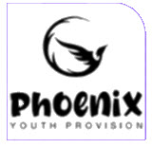
Accident / Incident Form - Phoenix Youth Provision
Project Name: Choose an item. Staff Details: Click to enter text
Date: Click to enter a date

Personal Information of Person / People Involved. (Use second sheet if needed).
First Name Click to enter text |  | Last Name Click to enter text
Phone Click to enter number |  | Date of Birth Click to enter date
Emergency Contacts  Name Phone Number |  | Address
Click to enter text | Click to enter | Click to enter text
Click to enter text | Click to enter | Click to enter text
Information about the Incident:
Location: Click to enter text | Time: Click to enter time hh/mm
Type: Incident / Accident/ Safeguarding
Behaviour Level: ☐Green ☐Amber ☐Red
Assessed Risk: ☐Green ☐Amber ☐Red
Description of Incident / Accident/ Behaviour. Including witness details. (Injuries, Risks, cause of issue / accident):
Click or tap here to enter text.
Action Taken: (First Aid, Police, Called Parents?)
Click or tap here to enter text.

Parent/Guardian Details
First Name Click or tap here to enter text. Surname Click or tap here to enter text.
Phone Click or tap here to enter text.
Parent Notified ☐ Yes ☐No
Address
Click or tap here to enter text.
Follow Up Actions Needed
Click or tap here to enter text.
Parent’s Comments
Click or tap here to enter text.

Staff Signature
Print Name
Date

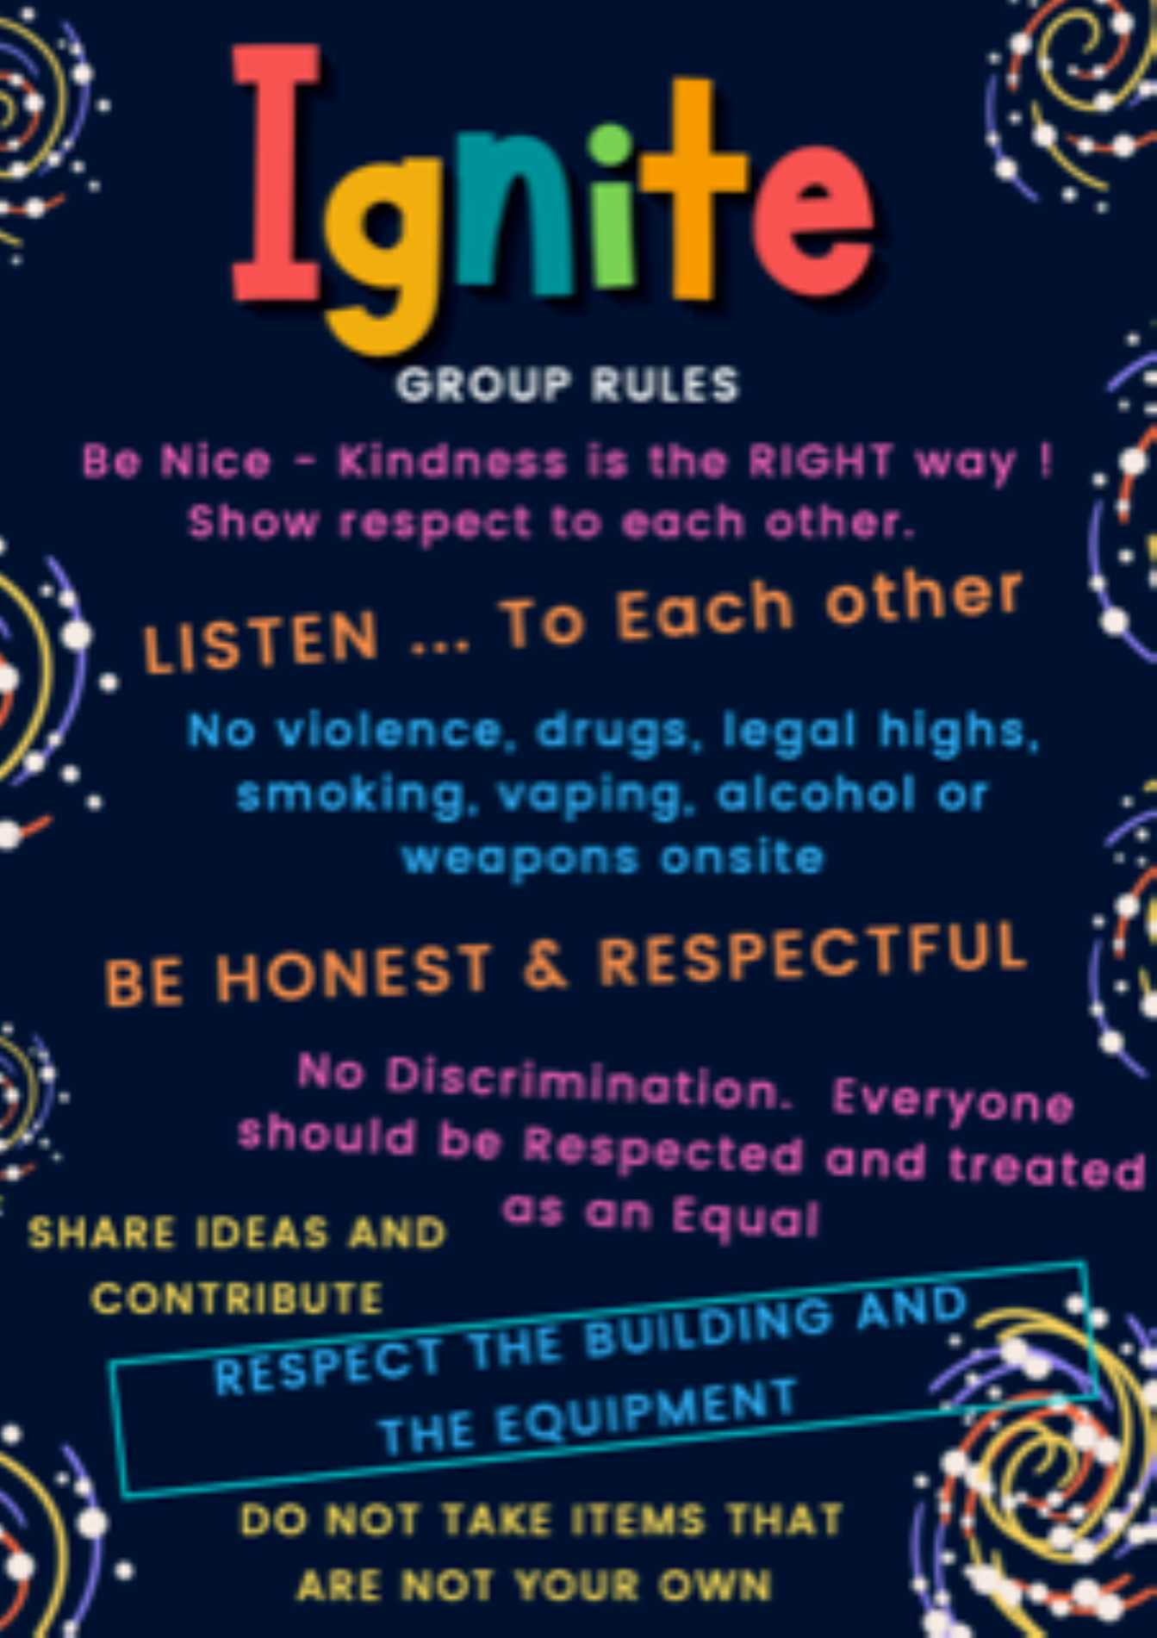
Ignite Group Rules

Behaviour Contract
At our Youth Group, we praise ourselves by doing:-
- Respect others as individuals - giving the other person our attention by listening politely and not making fun of what other people say.
- Respect other's culture, race, gender, background and the way they present themselves - realising that while we are all different, that deep inside we are all the same and individual.
- Take turns- let everyone have a turn and be fair when picking teams.
- Winning is not the only goal - understand that whilst winning is one goal - trying your best and shared teamwork matter too.
- Speak openly – but kindly and speak how you would like to be spoken to.
- Have the right to say “no” - if we don't want to take part in a specific activity, that's our right, but sometimes trying something new or different can also be fun.
- Don’t turn up to meeting early or at times when there is no meeting – This building is used for lots of other groups and we need to respect this at all times.
- Have fun and enjoy – our youth club was established to support you and have a safe place to come and meet others, however we also want you to have fun and meet new friends.
- Respect other people's possessions, this includes the club - don't damage other people's things or take anyone else's property without asking.

As a club we have decided to use a easy behaviour traffic light system, you will see posters showing Green, Amber and Red. You will see these around the building so you will understand our actions and why we have taken them.
Although we train our volunteers sometimes we sometimes get things wrong. It is important to calmly go to another member of staff and tell them what happened. If you feel you can’t for any reason, trust, for example. We will have a box that you can write a message (this may only be a number) and it will go to the Behaviour Manager.

'No Tolerance' (Red)
Along with general expectations of how young people should behave, a no-tolerance process of certain actions could also be implemented, which can include:
- No alcohol or drugs.
- No sexual misconduct, including harassment or discrimination.
- No violence and no gang activity.
- No weapons (knives included) or fireworks.
- No abuse to our volunteers who give up their time to give you a youth provision.
Young people act best when they know what is expected of them. Letting them have an input into how they should behave and why they should behave, is one step toward getting the behaviour you want.

